Computer Vision Internship

Week 2 Report

We applied filters to modify pixel value based on their neighbors. This enabled us to perform operations like blurring and edge detection.

We used 4 different types of filters, namely the Gaussian Filter, Median Filter, Average filter and the Bilateral Filter. Each filter has its own pros and cons.

We learnt to detect edges using the canny edge detector from the opencv library.

Lastly, I wrote an application that captures a picture from the webcam and converts it from video to a sketch format.

Average filter input:

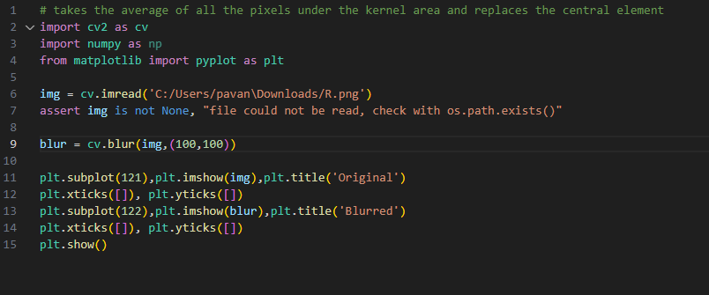

Average filter output:

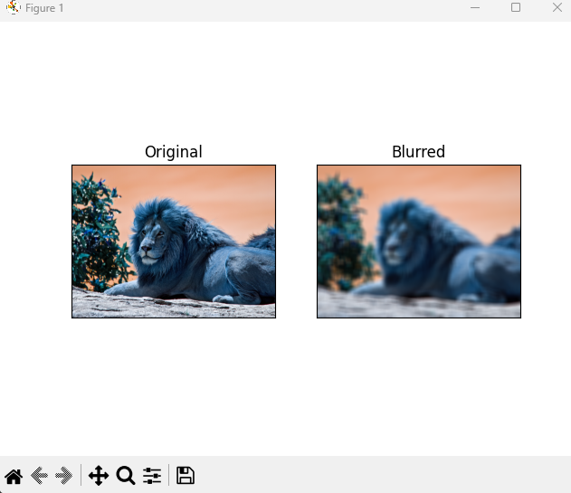

Bilateral filter input:

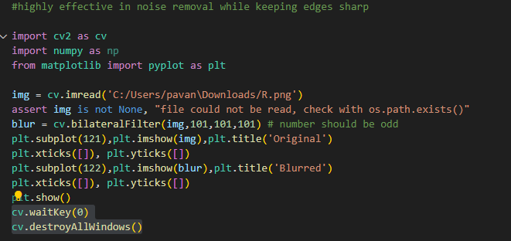

Bilateral filter output:

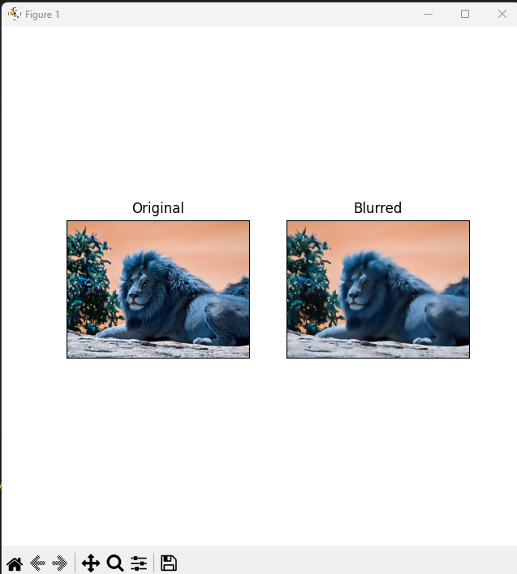

Gaussian filter input:

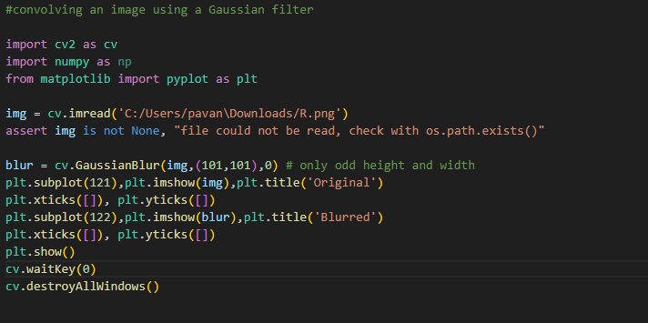

Gaussian filter output:

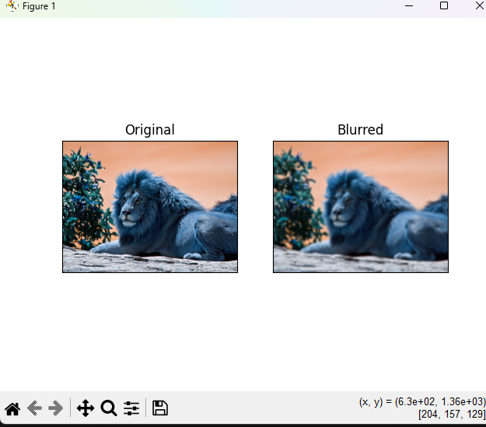

Median filter input:

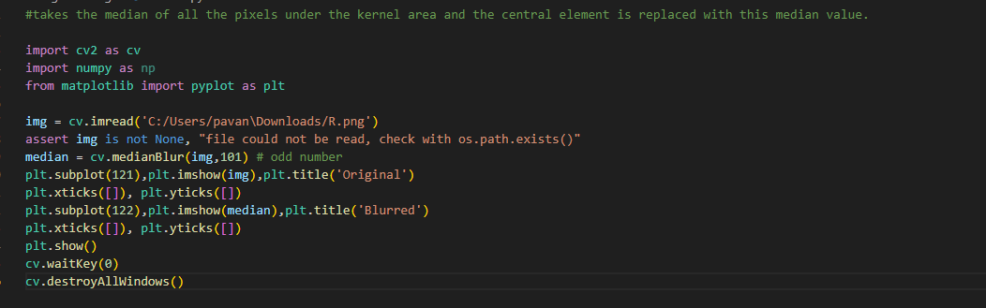

Median filter output:

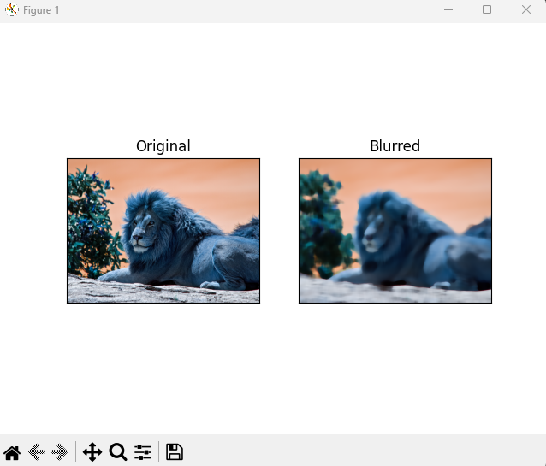

Detecting edges using canny:

Input:

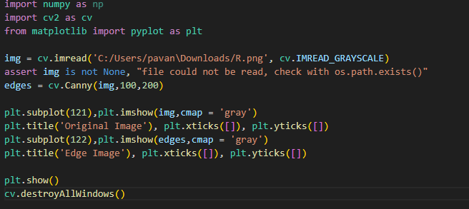

Output:

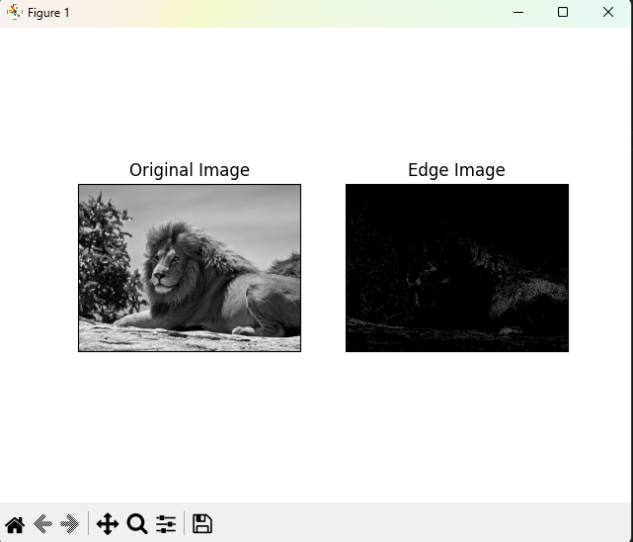

Exercise

Question:

* + Create an application that:
    - Captures video from a webcam.
    - Applies filters (e.g., Gaussian, bilateral) to remove noise.
    - Detects edges using Canny or Sobel.
    - Converts the processed video into a sketch format.

Exercise

Answer:

Input:

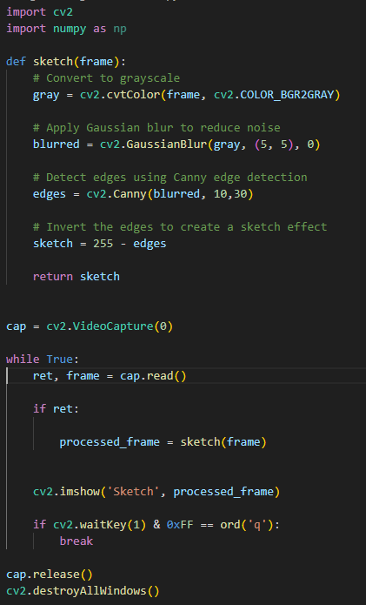

Exercise

Answer:

Output:

